**Range limits and plant migration in response to climate change in Neotropical montane rainforests**

Chlorophyll Fluorescence - a practical guide (Maxwell and Johnson, 2000)

* Used to gauge photosynthetic performance.
* Portable and user-friendly meters
* Light energy absorbed by chlorophyll can:
  + Drive Ps
  + Re-emitted as heat
  + Re-emitted as light (Chlorophyll fluorescence) (~1-2%)
* These processes must use up 100% of the incident light so increase in one causes decreases in the others
* Expose leaf to light of a specific WL and measure amount re-emitted at longer wavelengths which are known to be for fluorescence
* But this measure is relative, since light is always lost
* To remove the effects of background illumination, the machine is modulated (light turns on and off at high rate), so the receiver only picks up light from the machine
* When moving photosynthetic material into the light, it quickly increases its fluorescence. This is because electron receptors downstream of PS2 get reduced for the first time. The photosynthetic machinery gets jammed up and the light must be re-emitted.
* The level of fluorescence then begins to fall again over a few minutes. This is known as fluorescence quenching, occurs over 15-20 minutes until steady state is reached. This time varies between species.
  + There is an increase in the rate of electron transport away from PS2, due to activation of light-induced enzymes involved in carbon metabolism and the opening of stomata (photochemical quenching).
  + Increase in the efficiency of energy to heat energy (non-photochemical quenching).
* Must separate the effects of photochemical and non- , can normally switch off photochemistry:
  + Adding herbicides like Diuron to inhibit PS2, but is indesirable in a practical field experiment
  + Light-Doubling! A high-intensity short-duration flash of light closes all PS2 reaction centres. This creates a fluorescence yield equivalent to that obtained in the absence of photochemical quenching (Fm).
  + Compare Fm with the fluorescence at steady state (Ft,)and the yield of fluorescence in the absence of Ps light (F­o)
  + Gives info about the efficiency of photochemical quenching and thus the performance of PS2.
* Heat dissipation may vary (Fm), however it is not possible to completely inhibit heat dissipation. HENCE ALL ESTIMATIONS OF NON-PHOTOCHEMICAL QUENCHING ARE RELATIVE TO SOME DARK-ADAPTED POINT (FmO).
* So, must design experiments in a way that a dark-adapted non-stressed reference point can be estimated. Normally use the pre-dawn value of Fm.
* Photochemical quenching has been calculated in many ways:
* 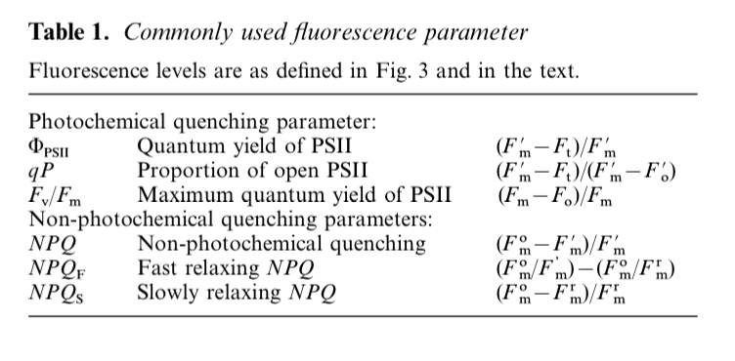
* 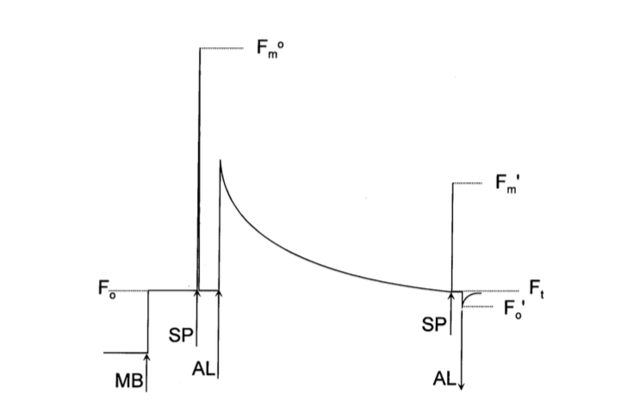
* A typical fluorescence trace:
  + MB = Measuring Light
  + Fo = 0 fluorescence
  + SP = Saturating flash of light
  + Fmo = max fluorescence in dark-adapted state
  + AL = Photosynthesis driving light
  + F’m = Max fluorescence
  + F’o = steady-state fluorescence immediately after the flash
* Quantum yield of PS2: proportion of light absorbed by chlorophyll associated with PS2 used in Photochemistry. Casn give a measure of the rate of linear electron transport so an indication of overall P­s.
* Under different stress conditions there may be a discrepancy between this measure and carbon fixation. Due to changes in the rate of Photorespiration or pseudocyclic electron transport
* Can also be used to measure linear electron transport rate and thus overall photosynthetic capacity *in vivo*
* But assumes: excitastion energy distributed evenly between PS1 and PS2
* qP gives the proportion of PS2 reaction centres that are open (1-qP gives proportion that are closed (Excitation pressure)
* Fv/Fm = measure of intrinsic efficiency of PS2 (*i.e.* the efficiency if all PS2 centres were open
* 
* Fv/Fm changes are caused by a change in the efficiency of non-photochemical quenching.
* Dark adapted Fv/Fm­ shows the potential PS2 efficiency, used as an indicator of plant photosynthetic performance. Changes in response to stress, *i.e.* photo inhibition
* In the field, measuring Fo is usually done by covering the leaf with a black cloth and providing far red light, this causes all the reaction centres to open
* Changes in dawn Fv/Fm may give info on the effect of env. Stress on the plant
* A change in NPQ demonstrates a change in the efficiency of heat dissipation, relative to the dark-adapted state. Can occur as a result of processes to protect the leaf from light-induced damage, or as a result of the damage itself.
* One of the protection mechanisms is high-energy-state quenching
  + Creates a low pH state in the thylakoid lumen and induces formation of carotenoid zeaxanthin a small % of quenching
  + Relaxes within minutes when placed in the dark.
  + Also state transitions (qT). involve the reversible phosphorylation of light-harvesting proteins, thought to be important in balancing the distribution of light energy between PS1 and PS2 at low light
  + The two forms of high-energy-state quenching cannot be easily distinguished by their relaxation kinetics, however qT is normally only present at low light levels, small contribution to overall quenching
* On a longer time scale, photoinhibtion occurs. This is the collective protective and damaging processes at the PS2 reaction centres
* Photoprotective processes with long relaxation times have been related to the presence of zeaxanthin and are found in the light harvesting antennae of PS2, causes changes in Fo. In contrast, damage processes occur within the PS2 reaction centre, does not cause changes in F­o.v This allows them to be distinguished in lab conditions.
* To analyse these phenomena:
  + Quenching relaxes and Fm is recorded at regular intervals.
  + Intervals between flashes to estimate Fm must be carefully considered as it takes time for the effects of a flash to return to steady-state (~5min). should record Fm over about 45min-1h
  + Produce graph of log Fm over time
  + Can then extrapolate to calculate value of Fm that would have been if only slowly relaxing quenching had been present in the light
* Whilst sun plants generally exhibit a higher capacity for high-energy-state quenching
* Shade plants vice versa and an increased likelihood of photoinhibition
* Alternative approaches to chlorophyll fluorescence analysis
* Can analyse kinetics of the fluorescence rise resulting from the transfer of a leaf from dark to light. Don’t have to use such expensive modulating fluorometers.
* But the analysis is still controversial
* CAN USE FLUORESCENCE TO ESTIMATE PHOTOSYNTHETIC PERFORMANCE, often the first manifestation of stress in a leaf.
* However, quantum efficiency of chlorophyll fluorescence is not directly analogous to photosynthesis rate
* Photosynthesis is the rate of carbon fixation, quantum efficiency of PS2 is the rate of electron transport, the two have a correlation that breaks down under field conditions.
* Caused by changes in photorespiration, nitrogen metabolism, electron donation to oxygen (Mehler reaction)
* Leaves growing in different microclimates will not have a constant ratio of light absorbed by PS2. Must combine with measures of gas exchange using IRGAs to accurately determine rate of Ps.
* Fluorescence measures can be used to:
  + Measure physiological constraints under different conditions.
  + Comparing the physiological habits of different species and functional groups.
  + Acclimation of plants to new conditions
  + Useful for measuring things such as lichen and bryophytes which don’t lend themselves to conventional IRGA analysis.
* Relating electron transport to carbon fixation
* Fluorescence is only in the top few layers of chlorenchyma whereas gas exchange is integrated across the whole leaf profile.
* Fluorescence and tolerating environmental stress
* Changes in Fv/Fm and Fo can indicate photoinhibitory damage caused by:
  + Low temperature
  + High temperature
  + Excess PFD (Photon Flux Density) (increased light)
  + Water stress